What reminds you most of beard? Playing with your dad? Kissing your boyfriend? Struggling to decide whether to shave or not in the morning? Beard seems to be the most common things in our daily life. It is so common that only a small proportion of people will pay attention to it and delve the meaning behind the vision, behind what your eyes take advantage of to “deceive” you.
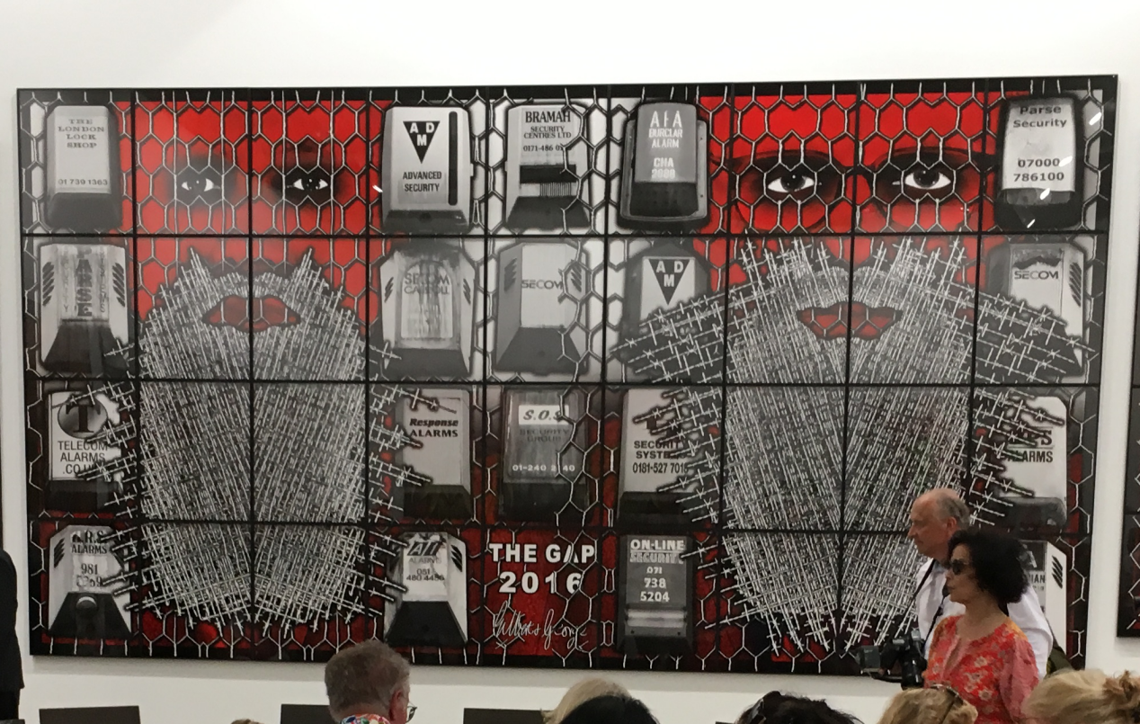
It is quite weird or “enigmatic” according to George, that the famous art duo chose beard as their theme although neither of them wear a beard in real life. “You switch on the news and you see barbed wire and bearded people. Good beard, bad beard; religious beard, non-religious beard. If you are a Jewish, Muslim, you are not allowed to cut beard,which interested us most as they are all fencing each other off.” explained Gilbert. As an exploration of our modern time, G&G used such contradictory and aggressive color to depict it. As the British writer and novelist Michael Bracewell states: “THE BEARD PICTURES are violent, eerie, grotesque, lurid and crazed. They show a dream-like world of paranoia and destruction and madness. Their strange sickly colors and creeping, smashed up, absurd landscapes confront the viewer with relentless aggression. They depict a world bereft of reason, in which negotiation no longer exists.”
As usual, the duo took themselves as the main character in the painting but the rest part is occupied by beard and barbed wire. Whenever you look at the painting, a strong sense of depression will pounce on you. Except the Beardology, their eyes are shadowed and bizarrely prettified. Possessed and serious, they seem to look at, into and through the viewer. They look as if their spirits might have gone away from their bodies with a feeling of sternness, absurdity, imprisonment, mocking and being mocked.
People behind the wire seems to be hiding from something, or, in another word, intentionally separate themselves from another group of people, not only due to the religious reason but far more than that.
Aggressively absurd, the security on the barbed wire symbolized the protocol and agreement countries signed to fencing themselves. In the central column of the painting, it’s easy to observe that some security boxes connect the rift of the barbed wire, breaking the original peaceful but subtle balance. US signed The Japan US Security Treaty to suppress the development of China merely because China and US have a totally different regime. Britain is now negotiating with EU for Brexit due to the annoying immigration problem.
Why? Why are they doing this? Is it because of religion? Is it because of race? People are separating themselves due to the difference from another community, causing wars, skirmishes, jealousy, hatred and brutality. During the Cold War, US got stuck so deeply into the Vietnam War that the impacts on veterans still exist until now. In the middle east, when Sunni and Shi’ite were battling and turned white-hot, terrorism occurs; family breaks; economy jeopardized. Focus on the last row of the painting, where the barbed wire broke.
As far as I’m concerned , that’s the best grid that needs the rest of the painting to support, an emblem that there is still some place where different people, various races, all kinds of religions can stay together peacefully. People don’t have to conceal themselves with bars and wires but can unveil themselves to everyone: I mean everyone.
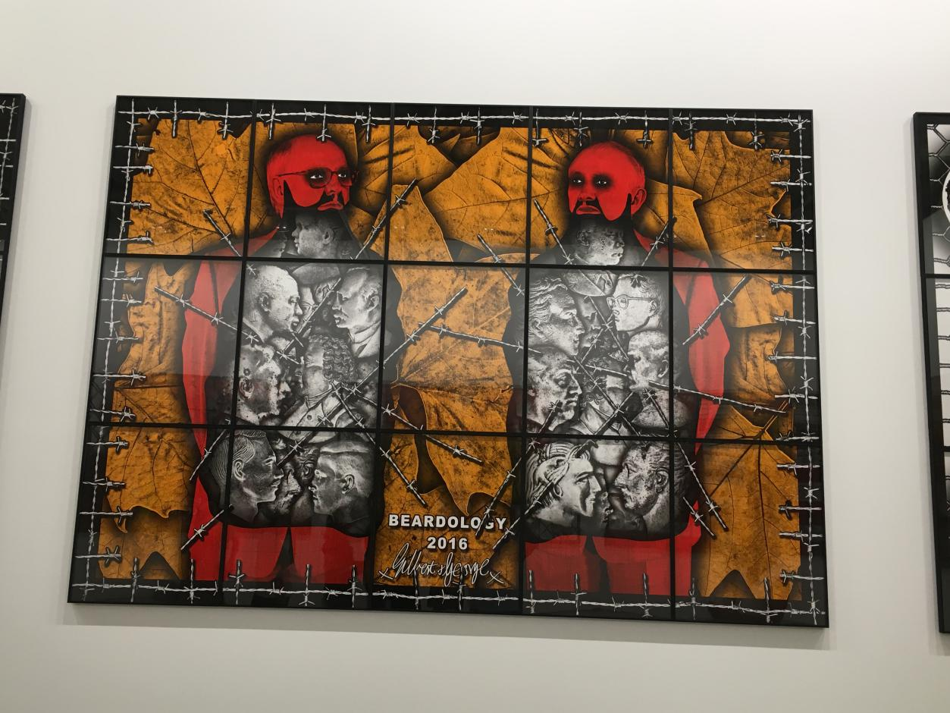
Still with a large amount of barbed wire, the color of the beardology seems to be more mitigated and temperate. The characters in the painting isn’t facing towards the audience but facing each other, symbolizing the start of a negotiation or a process to peace. The color used is not that dazzling and suppressing but warmer, lighter and more conciliatory. Their eye contact transformed from hostility and thoroughness to urge and hope. Observe the people inside the beard, they are more or less quite alike to the famous ideologists and politicians who have influenced one generation and another. As was expected, they are wrapped over with barbed wires and are separated into two parts，meaning that there were still conflicts and

